HUMAN RESOURCE ANALYTICS

**EXECUTIVE REPORT**

2006 - 2016

Contents

Introduction 1

Methodology 2

Key Findings 5

Recommendations 14

Conclusion 15

# **Introduction**

The executive report is based on the analysis of human resources department data of employees from 2014 to 2016 showing hiring, terminations, employee information and pay rate.

**Using various data analysis tools, we extracted, transformed, and loaded the data and develop data models and dashboard.**

The analysis would enable the executive team make informed decisions regarding recruitment, diversification of workplace, pay rate and gender equality.

# **Methodology**

**The data had some integrity issues but it didn’t have too much impact on the analysis.**

We employed various techniques and data analysis tools in achieving our goal. We used Power BI for data modeling, reporting and visualizations. Power BI is a powerful data analytical tool that enables us dissect the data and come up with actionable insights.

* **Data Cleaning and Analysis Processes include;**
  + The data was extracted from excel and loaded into Power Bi. Various transformations and data cleaning processes were done using Power Query, which include checking data type accuracy, replacing incorrect and incomplete data rows, removing blank rows,
  + Various calculated columns, measures and table were created to facilitate the analysis.
  + **Calculated Columns include;**
    - Working Status - to separate terminated and employed workers
    - Pay Rate Level – to categorize low, mid and high-income earners. Values used were >= $40 for high, >=$20 for mid and lower for < $20
    - Age Group - for grouping the different age ranges.
  + **Measures created include;**
* Average Age
* Average Pay Rate
* Previous Year Employees
* Previous Year Male Employees
* Previous Year Female Employees
* Total Departments
* Total Male Employees
* Total Female Employees
* Total Working Employees
* Total Working Male Employees
* Total Working Female Employees
* Total Terminated Employees

A calendar table was also created to effectively implement time intelligence on the dataset.

* **Limitations or constraints faced during the analysis include;**
  + Data integrity issues were found in the data set.
    - 2 employees Ndzi, Colombui and Ndzi, Horia share the same employee number 1204033041. This could have been an error from entry but neither could be removed because they don’t share the same info except for the emp no. This would have to be resolved from HR.
    - An employee Howard Estelle was terminated on 04/15/2015 but is still kept as an active employee. This makes him a ghost worker.

# **Key Findings**

Dashboards created include;

**Executive Dashboard**

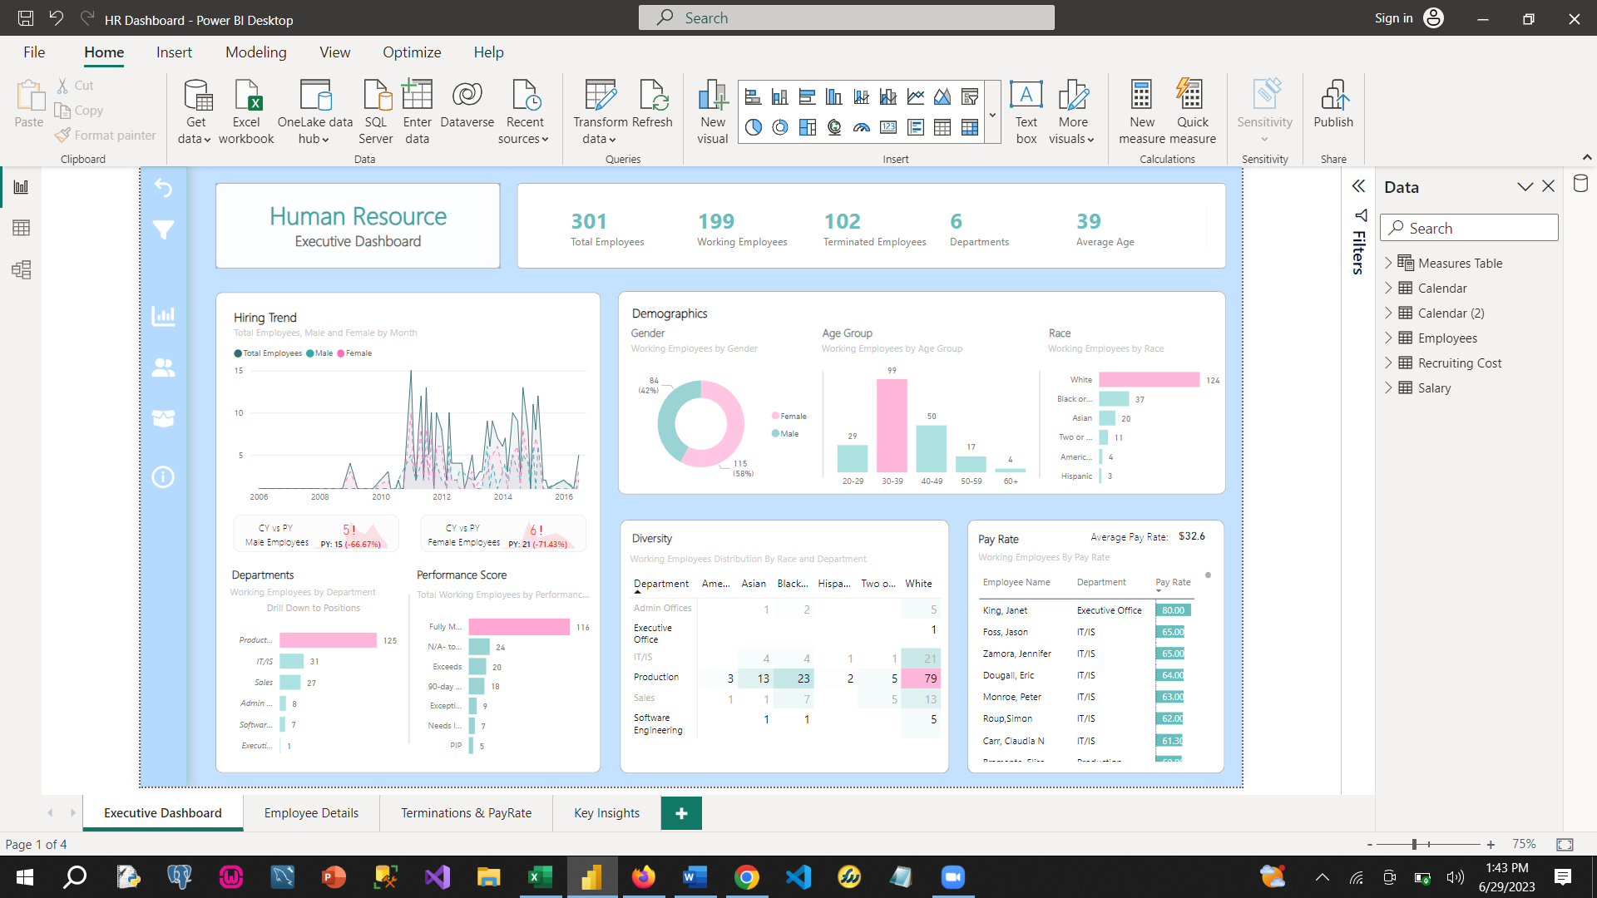

**Employee Details**

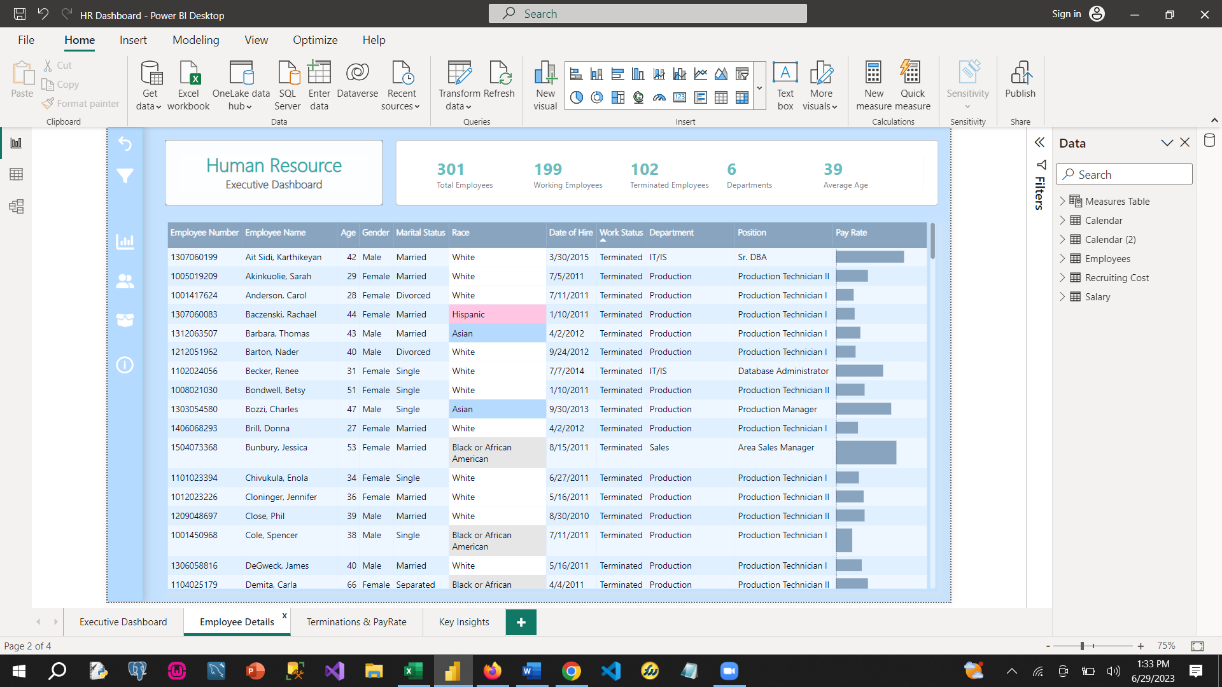

**Terminations and Pay Rate**

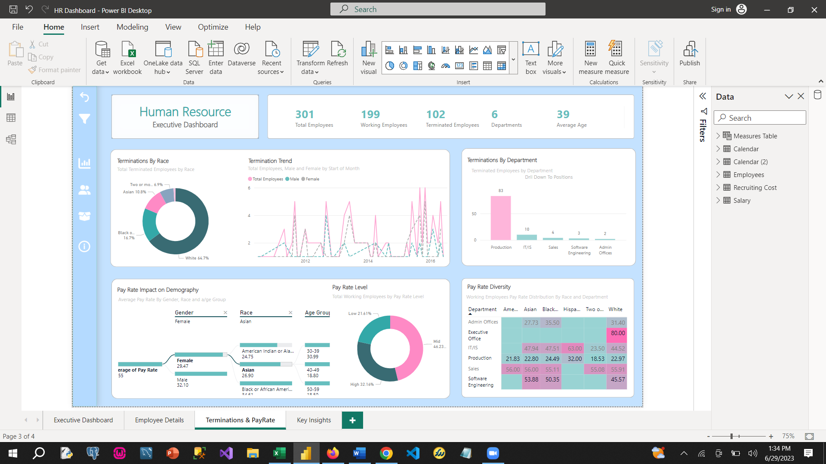

**Key insights and trends obtained from the data include;**

* **In January 2011**, the highest monthly employment was recorded with 10 females and 5 males.

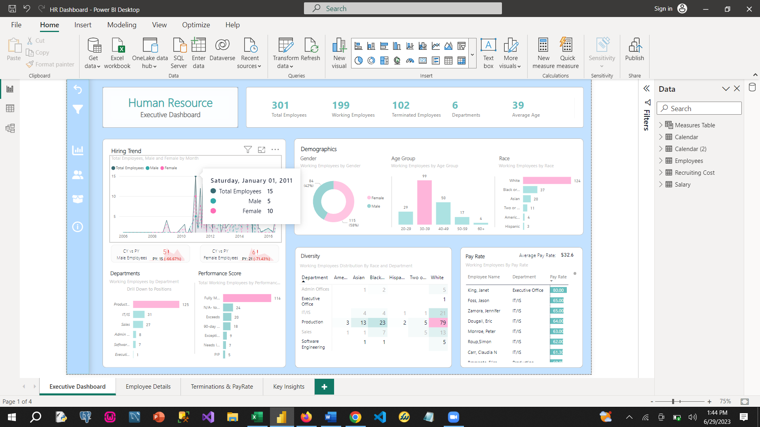

* **White employees make up over 60% (124 employees) of the entire work force** with majority of them working in the production department with a total of 79 followed by blacks with 23 employees.

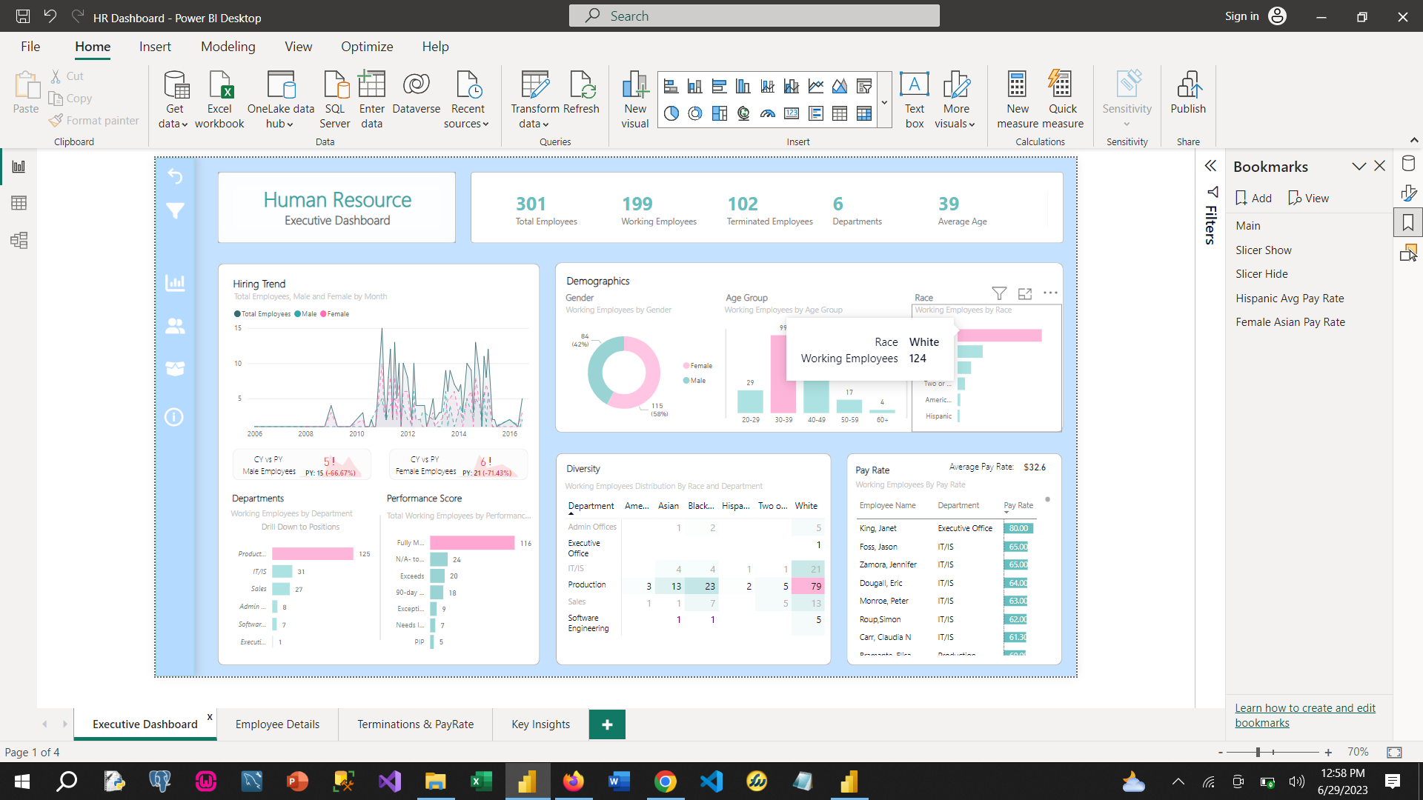

* There are more females than males in the company; females make up **58% of the employed staff while males make up 42%.**

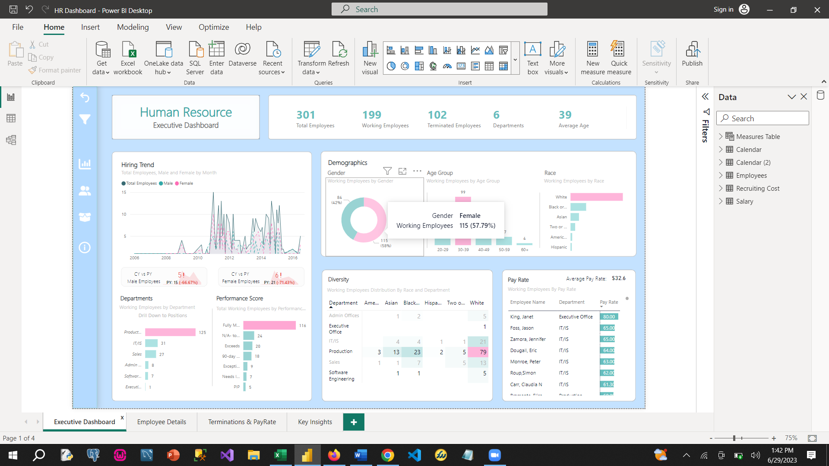

* More white employees have been terminated from the company than any other race with a **total of 64.7% since 2010**.

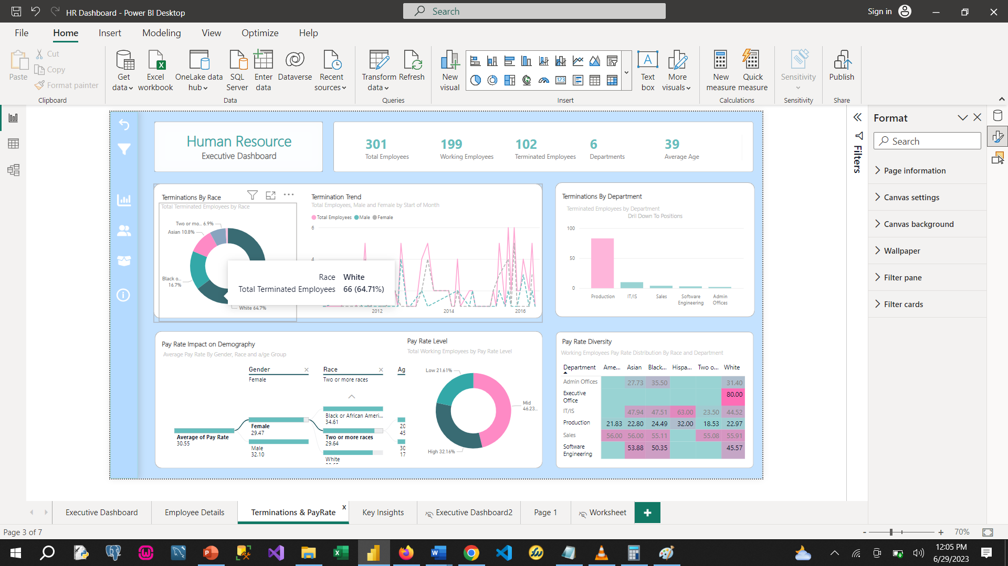

* Although white employees hold the biggest office in the company taking home a **whopping $80 pay rate**; the Hispanic race take home the highest average pay rate in the company with **$47.3 pay rate**.

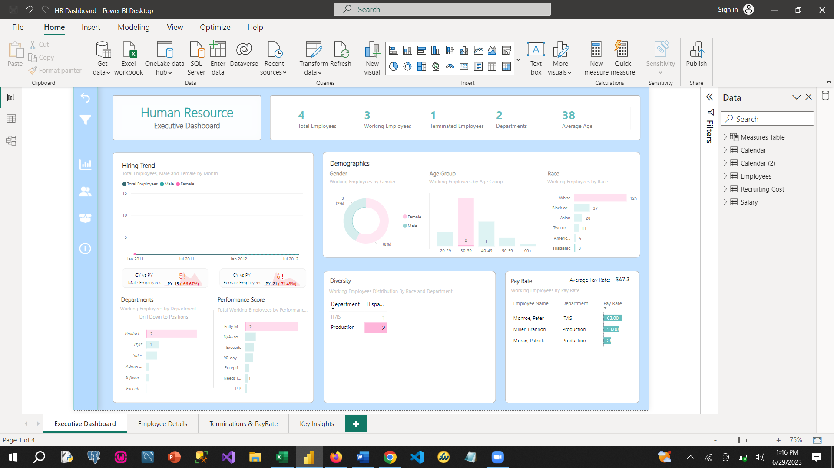

* The **production department** has the highest number of employees and the highest number of terminations with a total of 83 employees of the terminated employees, and **Production Technician 1** position recording the highest terminations with 52 employees.

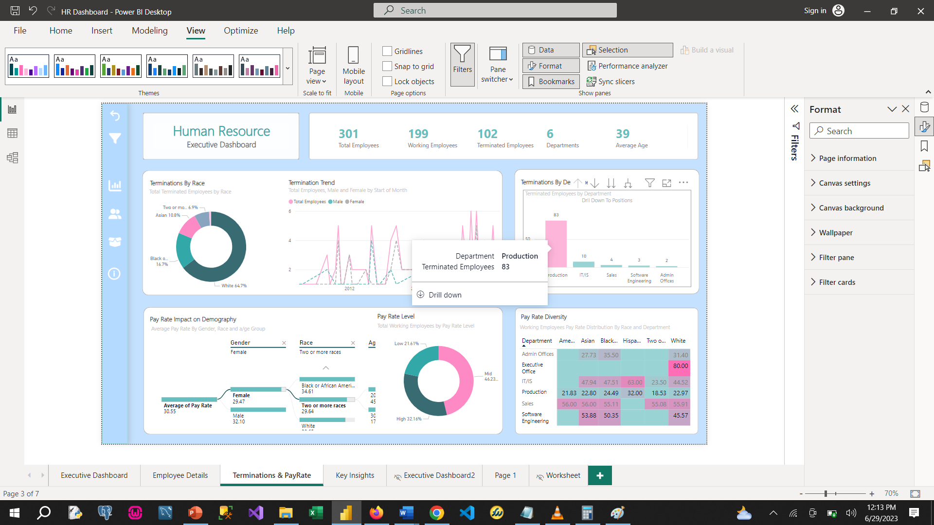

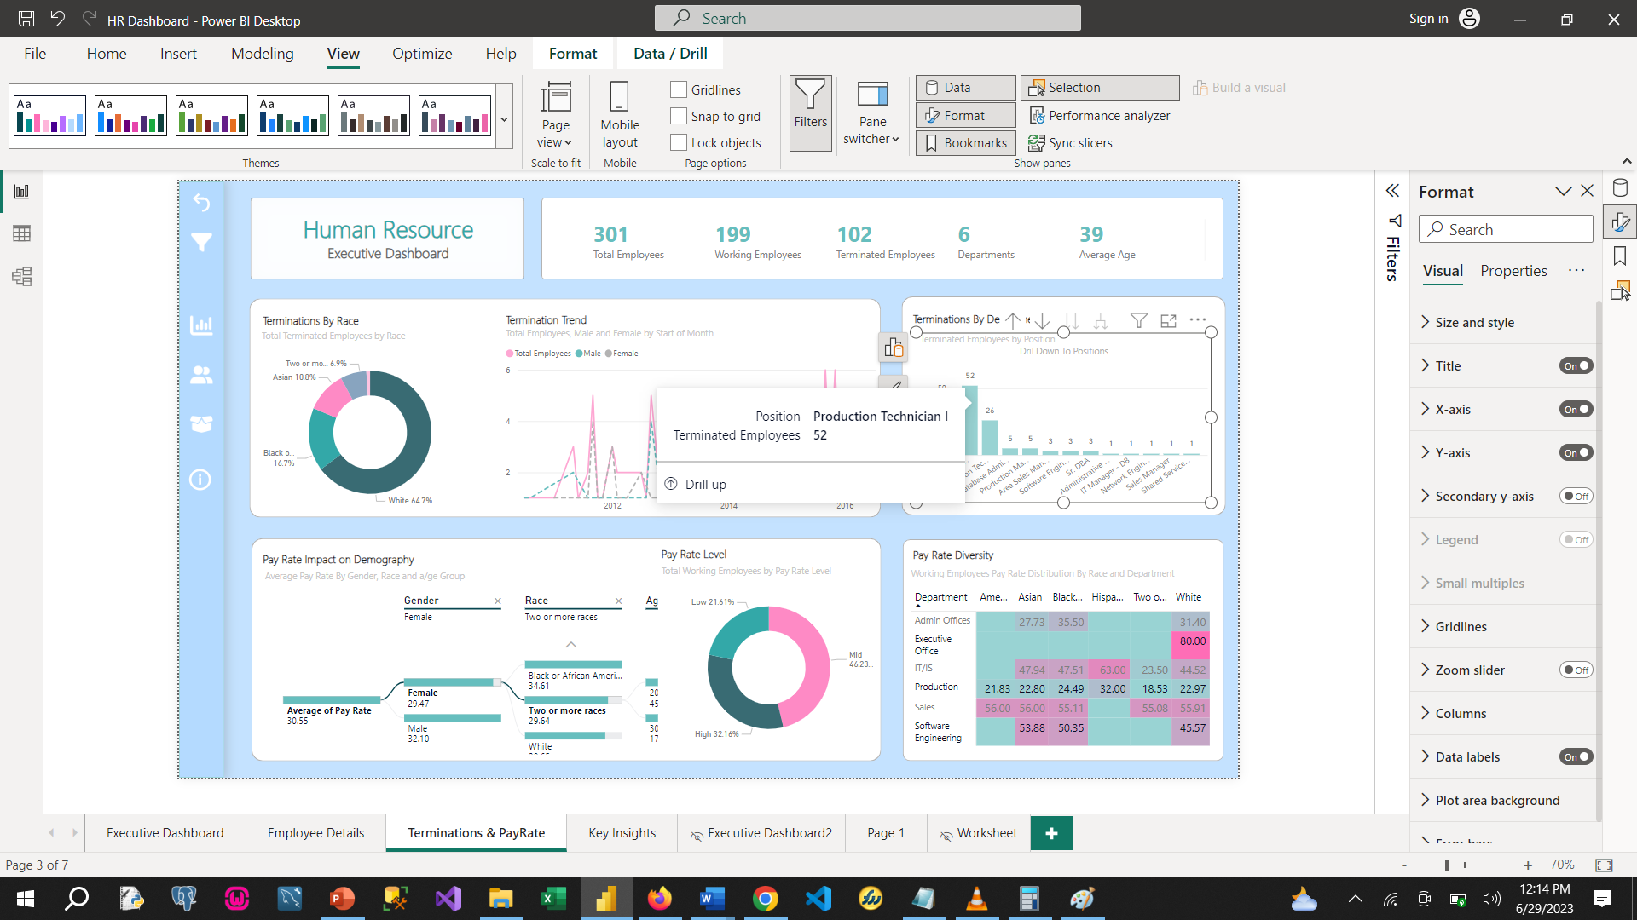

* **About 50% of the entire workforce** is within the **ages of 30 to 39** years, creating a vibrant and strong workforce.

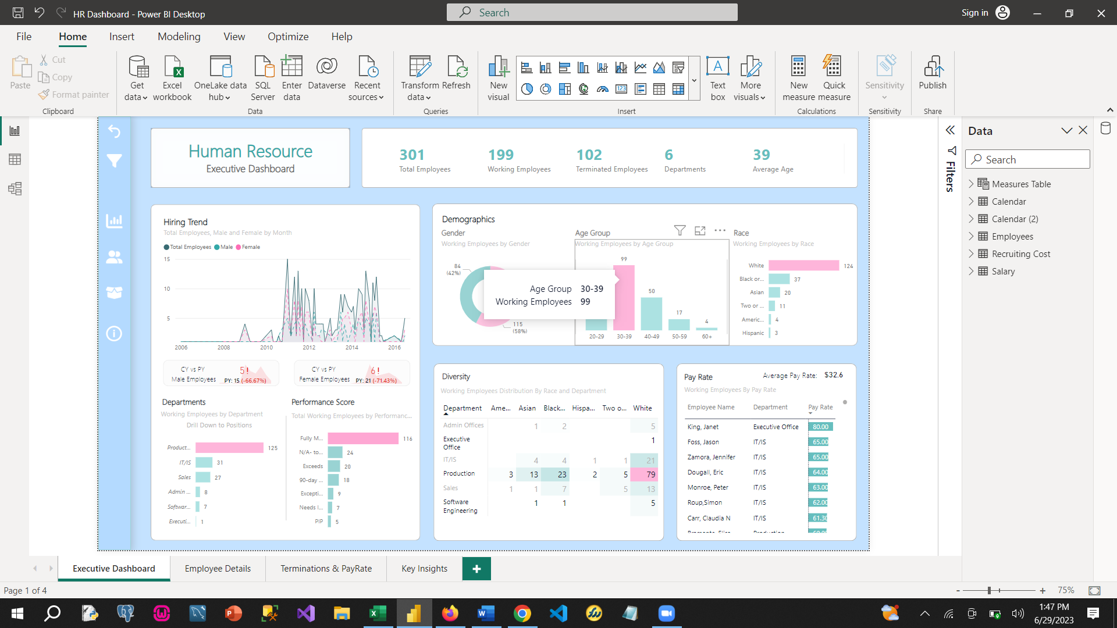

* **Female Asians between the ages of 40 – 60** seem to be greatly impacted by the low pay rate with an **average of 18%** including females with 2 or more races within that same age group.

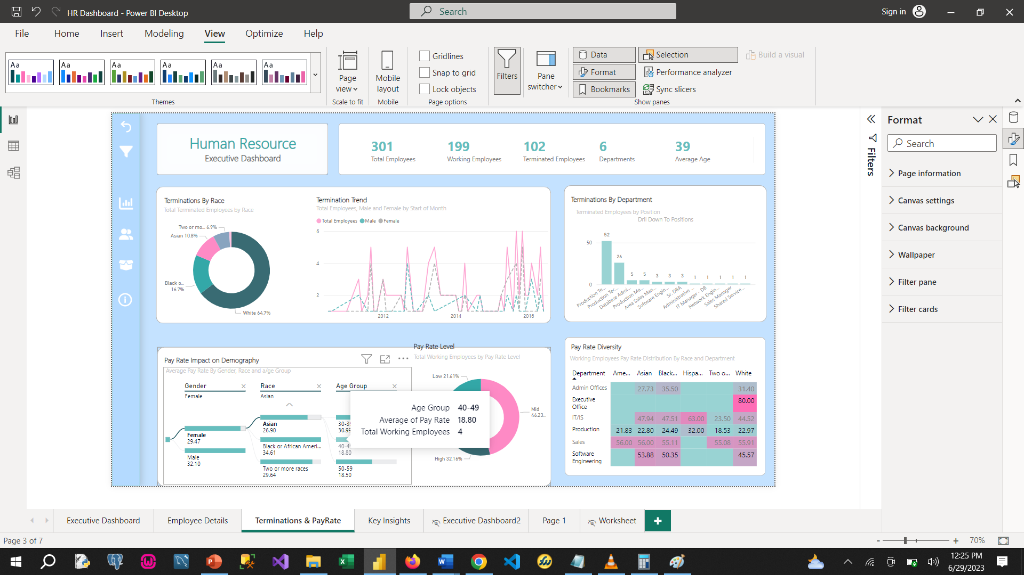

# **Recommendations**

Based on the analysis, propose **actionable recommendations** include;

* To promote diversity, the company would need to **recruit more from other races**
* The pay rate for **female Asians between the ages of 30 and 60** is quiet low and should be reviewed upward to boost productivity and encourage growth.
* **Other races should be recruited into the production department** which is currently dominated by whites to boost diversity in that department. This seems to be one of the most important departments in the company.
* **Gender equality could be improved by recruiting more males** which is currently at 42% of employees currently employed in the company.

# **Conclusion**

In conclusion the dataset was very helpful in understanding diversity, hiring, terminations and pay rate amongst others.

The HR department should endeavour to improve diversity, gender equality and an overall better pay for all races.